4th Formby (Holy Trinity) Scout Group Minibus.
Information for Hirers

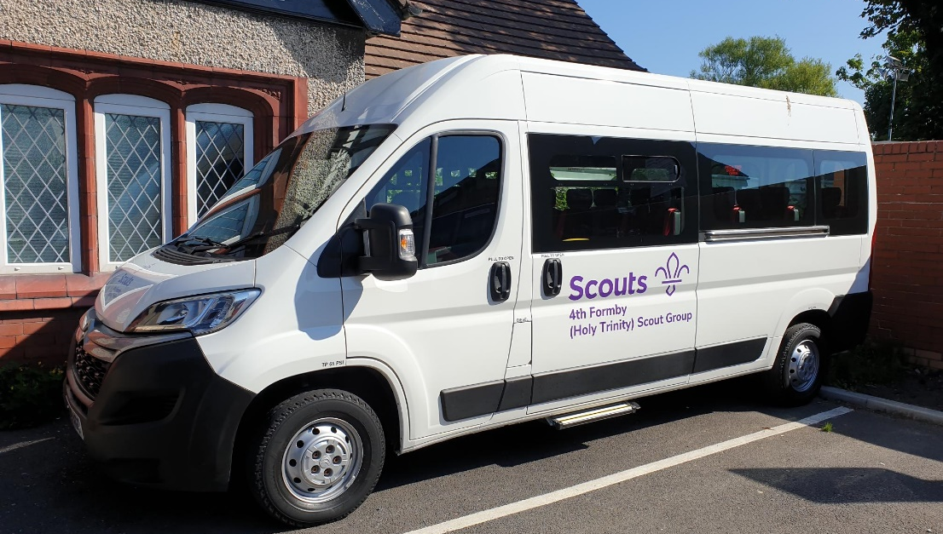

About our Minibus
The 4th Formby Minibus was purchased mostly with funding from the Youth Investment Fund. It is a Citroen Euro 6 Relay L3H2 17-seater (16 passenger seats). It also has wheelchair ramps and 4-point wheelchair restraints, which if used reduces the capacity to 12 passenger seats.

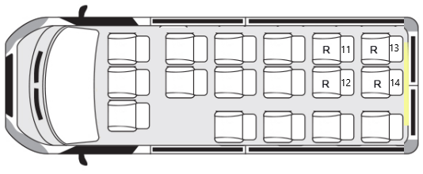
Who can drive the Minibus.
The Minibus has been converted for disabled use and is under 4.25 Maximum Authorised Mass and is driveable in the UK by anyone over 25, and under 70, with two years of driving experience on a standard UK Category B license for non-hire or reward.

Weight
The Minibus has a maximum weight on the road of 3850kgs. When picked up, it will come with a full tank of diesel, plus all of the equipment listed below and will weigh 2525kgs. This gives you an available load of 1325kgs.

Equipment
The Minibus is Euro 6, ULEZ and CAZ (Clean Air Zone) Compliant, with a 6-speed manual gearbox and has air-conditioning in the front cab, along with cruise control and parking sensors plus a current SatNav. It is equipped with 4 way heated electric mirrors. It has DAB/FM Radio with Bluetooth connectivity and USB/auxiliary jack input, with additional speakers in the rear cabin. Also, the upper passenger glove box is cooled. It will stop your chocolate melting in the summer

The 14 rear passenger seats come equipped with “all age” adjustable 3-point seat belts.

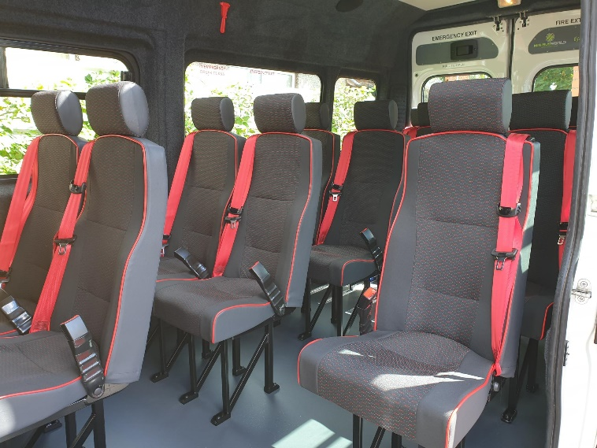

4 of these seats are removable to allow for occasional wheelchair use. The wheelchair restraints and ramps are always stored in the vehicle.

Stored in the vehicle will be the vehicle information file, containing the daily logbook, daily check list, insurance, breakdown and MOT details, along with payload sheets.
The driver’s handbook is also provided. In the vehicle is the toolkit, First Aid Kit, Fire Extinguishers, Emergency Hammers, Emergency Tyre Repair Kit (Note. The minibus does not have a spare wheel), Tyre Pressure Gauge, Yellow Hi Viz waist coats, Sick bags & wipes.

Using the Minibus.
As part of the hire agreement, please ensure you maintain the vehicle logbook sheet whilst the vehicle is in your care. Please complete and sign for the Daily Check. A copy of which is located on the inside cover of the information file.
Remember, you are responsible for the Road Worthiness when on hire.

Returning the Minibus.
Please arrange a drop off time when you collect the Minibus.
Please return the Minibus full of fuel, clean both inside and out. We reserve the right to charge cleaning fee if the Minibus is returned dirty.
Ensure you complete the final mileage on the Logbook and record any defects.

